1 2 3 4 5 6 7 8
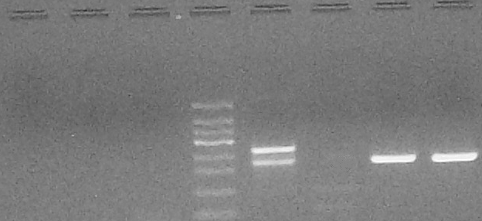

Supplementary Figure 1. Example of 5’NCR RT-nested-PCR products run on an agarose gel electrophoresis. UV light revelation after 2% agarose gel electrophoresis of RT-n-PCR products. Lanes 1-2 = reaction controls; lane 3 = negative control; lane 4 = molecular weight standard marker, 50 bp; lane 5 = positive control; lanes 6-8 heart transplant patient samples. From lane 5 to 8 wells were loaded with aliquots of 1st round (261 bp) and 2nd round (218 bp) PCR products.

